1. Create New Folder - capstone

2. Move folder capstone-rrr-app inside the new folder (capstone)

3. Create another folder inside capstone folder - rename it to capstone-server

4. Open VS > Open Folder Capstone

5. Open New Terminal > cd capstone-rrr-app

6. npm start

7. Open another terminal go to node of capstone-rrr-app and click on split terminal to open a new terminal

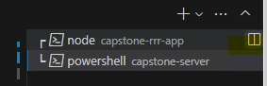

8. cd .. > cd capstone-server > npm init > enter lang ng enter gang tanungin ka ng Is this Ok? Click Enter ulit.

9. After creation a package.json should be created under capstone-server

10. You can go to package.json and update the description (input “backend file”)

11. Create a new file under capstone-server name it to index.js

12. Go to server terminal > npm install express body-parser mysql nodemon cors then Enter.

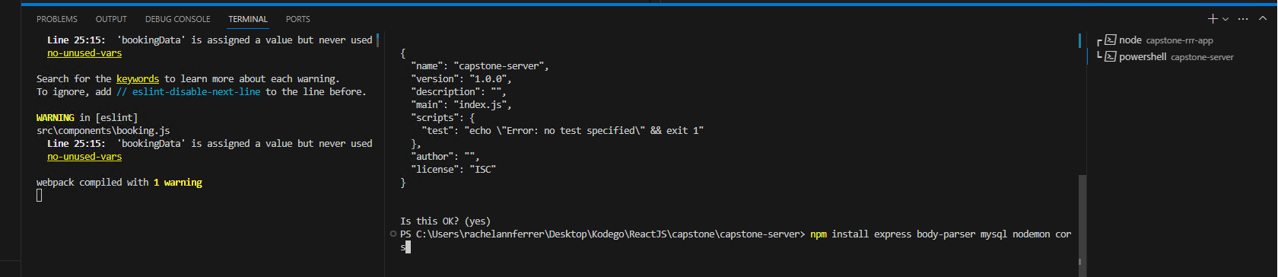

**After successful installation node_modules should be added and dependencies on package.json will be updated

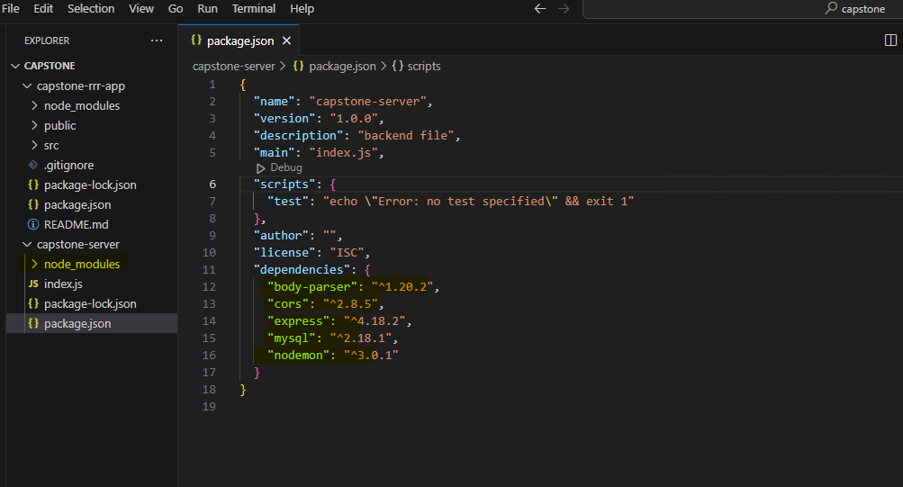

13. Update index.js

const express = require("express");

const bodyParser = require("body-parser");

const mysql = require("mysql");

const cors = require("cors");

const app = express();

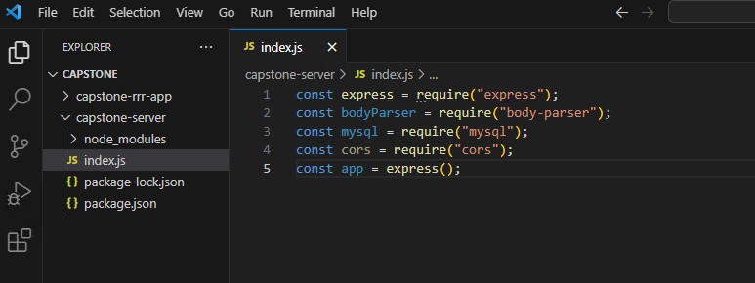

14. Update index.js

app.listen(3001, () => {

    console.log("running on server 3001");

})

To check if running – type on the terminal of server > node index.js

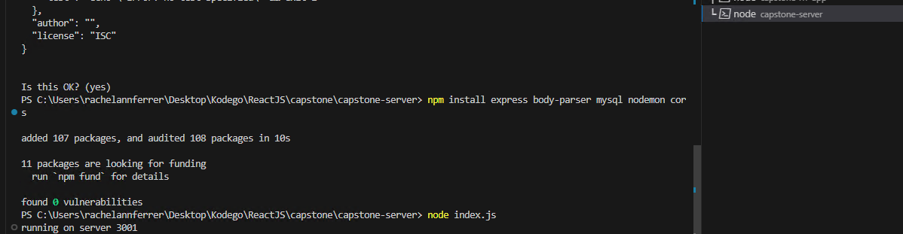

15. Update your package.json > Go to Scripts > add the following:

    "start": "node index.js",

    "devStart": "nodemon index.js",

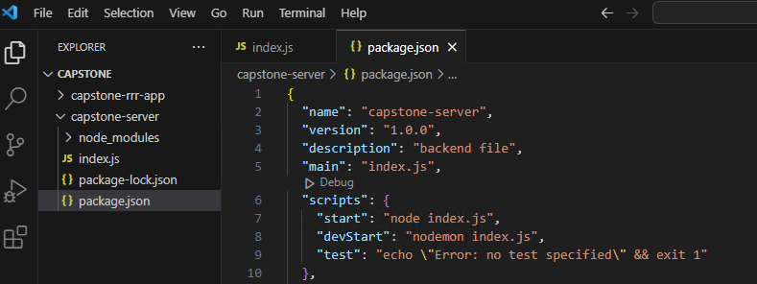

16. Go to the server terminal again > CTRL + C > npm run devStart

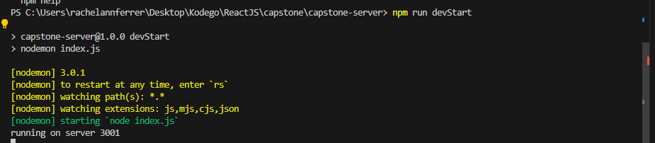

16. Create a variable for PORT.

const PORT = 3001;

17. Update the console.log to call on var PORT

console.log(`running on server ${PORT}`);

18. Create connection to the db.

const db = mysql.createPool({

    host: "localhost",

    user: "root",

    password: "",

    database: "capstone"

})

Zoom Recording Link - [WD75 || Wednesday || 1:00pm - 6:00pm - YouTube](https://www.youtube.com/watch?v=cp1PIuwRwp0)